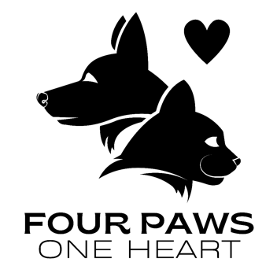

Sponsorship Form

Thank you for sponsoring one of our wonderful rescue dogs.

Every donation you make goes towards the dog's rehabilitation, and a journey to a new life.

Without your support, it’s all impossible.

Thanks to people like you, the dog's lives are changed forever.

* Your name-
* Name of dog you would like to sponsor-
* Would you like to sponsor monthly or weekly?
* How much would you like to donate? £
* Would you like to receive quarterly updates on your chosen dog's progress?  
  If so please provide your email address
* ...........................................................

Thank you so much from Georgia, The team, and most importantly all the dogs in the care of Four Paws One Heart. ❤️

Please email the completed form to [fourpawsoneheartrescue@gmail.com](mailto:fourpawsoneheartrescue@gmail.com)

Bank details for payment/Standing order

Georgia Lane Molloy

20-45-77

60337277

Reference: Dogs Name.

Information:

All donations go towards the veterinary bills, medication, food, boarding, vaccinations and routine medications for flea and tick treatment.